

Ministry of Higher Education and Scientific Research

Al-Iraqia University

College of Engineering

Network Engineering Department

Design and Implementation of an educational game for Kids using C#

BY

Mariam Hassan Radhi

Faisal Ahmed Faisal

Supervisor

Lecture Othman Atta

2023-2024

**DECLARATION**

We hereby declare that this project report is based on our original work except for citations and quotations, which have been duly acknowledged.

Name : _________________________

Signature : _________________________

Date : _________________________

Name : _________________________

Signature : _________________________

Date : _________________________

**APPROVAL FOR SUBMISSION**

We certify that this project report entitled **“Design and Implementation of an educational game for Kids using C#”** was prepared by **Mariam Hassan Radhi and Faisal Ahmed Faisal** has met the required standard for submission in partial fulfilment of the requirements for the award of Bachelor of **Networks Engineering** at Al-Iraqia University.

**Approved by**

Supervisor : _________________________

Signature : _________________________

Date : _________________________

**ACKNOWLEDGEMENTS**

Firstly, we would like to thank everyone who contributed to the successful completion of this project; we would also like to thank our Research Supervisor, Lecture Othman Atta, for accepting our project and cooperating with us. And we would like to express our special thanks of gratitude for network engineering department officials for encouraging us and supporting and guidance in a timely manner until the completion of our project work.

**ABSTRACT**

Several studies have demonstrated the positive effects of educational games on children's cognitive development, academic performance, and motivation. Research suggests that well-designed games can improve learning outcomes by promoting active engagement, problem-solving skills, and knowledge retention. Educational games are recognized for their ability to enhance children's engagement and motivation in learning activities. By integrating elements of play and challenge, games can foster intrinsic motivation and sustained interest in educational content. Studies comparing digital and physical educational games suggest that both modalities offer unique benefits and challenges. Digital games provide opportunities for interactive learning experiences and personalized feedback, while physical games promote social interaction and tactile engagement. The goal of this game is to teach children some general information in various specializations, to increase the children’s cultural level and instill in them the spirit of learning and knowledge, by giving them some tests in the form of a game so that they can benefit while playing. The game is designed to be easy to use for children, as children can choose topics and answers easily, and of course the questions are suitable for children. This game aims to make some of the time children spend using the Internet productive by teaching them some things that will benefit them in school or real life.

**Table of Content**

|  |  |
| --- | --- |
| **Title** | **Pages** |
| **DECLARATION** | **II** |
| **APPROVAL FOR SUBMISSION** | **III** |
| **ACKNOWLEDGEMENTS** | **IV** |
| **ABSTRACT** | **V** |
| **Table of Content** | **VI** |

**Chapter one**

**INRTODUCTION**

|  |  |  |
| --- | --- | --- |
| **1.1** | **Background** | **9** |
| **1.2** | **Problem statement** | **10** |
| **1.3** | **Aims and objectives** | **11** |
| **1.4** | **Literature Review** | **12** |

**Chapter two**

***Methodology***

|  |  |  |
| --- | --- | --- |
| **2.1** | **Introduction** | **15** |
| **2.2** | ***Project description*** | **15** |
| **2.3** | ***Programming*** | **16** |
| **2.3.1** | **C#**  ***Advantages of C#***  ***Disadvantages of C#*** | **16**  **17**  **18** |
| **2.3.2** | ***Visual Studio 2022***  ***Advantages of Visual Studio 2022***  ***Disadvantages of Visual Studio 2022*** | **18**  **19**  **20** |
| **2.3.3** | ***Server Management Studio (SSMS)***  ***Advantages (SSMS)***  ***Disadvantages (SSMS)*** | **21**  **22** |

**Chapter three**

## **Results and Discussions**

|  |  |  |
| --- | --- | --- |
| **3.1** | **Introduction** | **25** |
| **3.2** | **Advantages and Disadvantages** | **25,26** |
| **3.2.1** | **Feature and Advantage** | **25** |
| **3.2.2** | **Disadvantage** | **25** |
| **3.3** | **Non-Functional requirements** | **26** |
| **3.4** | **User interface design** | **27** |
| **3.4.1** | **Create account page** | **27** |
| **3.4.2** | **Login page** | **28** |
| **3.4.3** | **Categories** | **30** |
| **3.4.3.1** | **Geography** | **31** |
| **3.4.3.2** | **Sciences** | **32** |
| **3.4.3.3** | **Challenge** | **33** |
| **3.4.3.4** | **Math** | **35** |
| **3.4.3.5** | **Stories** | **37** |
| **3.4.4** | **Database** | **38** |

**Chapter four**

**Conclusion and Future Work**

|  |  |  |
| --- | --- | --- |
| **4.1** | **Conclusion** | **41** |
| **4.2** | **Future Work** | **42** |
|  | **References** | **43** |

***Chapter One***

**Introduction**

**This chapter will be an introduction to kids games and its Advantages and disadvantages**

**Chapter One**

**Introduction**

* 1. **Background**

Kids games are a fun and interactive way for children to learn, develop skills, and have a great time. They come in various forms, including digital games, board games, outdoor games, and more. These games are designed to be age-appropriate and often incorporate educational elements to support learning and cognitive development. They can help children improve their problem-solving abilities, creativity, social skills, and hand-eye coordination. Whether it's playing online games, exploring nature, or engaging in imaginative play, kids games provide a wonderful opportunity for children to grow and have fun at the same time

With the expansion of access to and use of information and communication technology - especially mobile phones - significantly in the first decade of the twenty-first century, the spread of smartphones has increased in society, especially among young people and those under the age of youth, and phones are available in all homes, so mobile devices have become increasingly popular and connected to our daily lives, new applications are constantly being made available that make our lives easier. These developments prompted teachers and researchers to use these devices to enhance teaching and learning and thus necessitated the need to employ learning by phone. In addition to the great technological progress that the world knows today, it has become necessary to add new foundations for education and development in general, and this refers to the use of technological applications and benefits from them in all areas of life and to achieve to this end, we propose to create an Android application that provides children with an interactive way to learn some mathematical operations

* 1. **Problem statement**

1. children in our current era turning to games that waste time, effort, and money, and turning to some applications that encourage fighting and violence, which we notice in our societies the large number of crimes, and violence among children from time to time. Therefore, games that combine learning and fun must be provided.
2. The inadequacy of the use of technological knowledge applications in childhood and the inadequacy of investing these applications in achieving the comprehensive cognitive development of the child, that they are limited at present to being modern technological means of entertainment, entertainment and play such as fighting games, violence, and others.
3. Children'sinterest in science and culture has declined, as many children no longer possess the most basic information about science, the history of countries andtheircultures, including the history, geography and culture of their countries.

**1.3 Aims and objectives**

1.Building an educational game for children that teaches them some basic arithmetic operations and some information about history, geography, and science

2. Building an interactive game that contains colors and graphics to suit children’s interests and ensure that they do not feel bored while using the game.

3.Simplifying general information for children so that it can be learned more easily, as many children feel bored when learning mathematics or reading books about history, geography, and science, so putting it in a game will combine fun and benefit.

4.the study of mathematics, science and other academic subjects for children, away from traditional methods that children find boring. Putting it into a game will make it easier and more fun to understand and will result in an investment of time and effort.

**1.4 Literature Review**

* Educational kids games have gained prominence due to their potential to enhance learning experiences. Research suggests that such games foster cognitive development, improving skills like problem-solving and critical thinking. Studies by Gee (2003) emphasize the positive impact of video games on literacy skills[1], highlighting the potential for interactive learning. Additionally, the work of Steinkuehler and Duncan (2008) explores the social aspects of gaming[2], emphasizing how collaborative play in educational games can contribute to a supportive learning environment. However, concerns about screen time and the need for balanced, offline learning experiences are also addressed in the literature (Hirsh-Pasek et al., 2015)[3]. In conclusion, the literature indicates that educational kids games offer a valuable tool for holistic learning, but careful consideration is required to strike a balance in their use.
* Recent studies by Miller and Robertson (2021) delve into the impact of educational games on motivation and engagement[4]. Their findings suggest that well-designed games can increase students' intrinsic motivation, making learning enjoyable and meaningful. Furthermore, the research of Johnson et al. (2019) emphasizes the importance of aligning game content with educational objectives to ensure effective learning outcomes[6].
* Examining the cultural dimensions, studies by Squire (2006) explore how educational games can be designed to be culturally relevant[8], enhancing the inclusivity of learning experiences. This highlights the potential for games to bridge educational gaps and cater to diverse backgrounds[9]. Moreover, ongoing research by Prensky (2018) focuses on the evolution of educational games in the digital age[10], discussing the integration of emerging technologies like augmented reality and virtual reality[11]. These advancements offer new possibilities for immersive and interactive learning experiences, pushing the boundaries of traditional education.In summary, the literature on educational kids games underscores their multifaceted impact on cognitive development, motivation, cultural inclusivity, and the evolving landscape of digital learning tools. Continued exploration and innovation in this field hold promise for shaping the future of education[12].
* There is a dearth of research targeting other areas of early math development, such as spatial skills, in culturally and linguistically diverse families. Additionally, research often overlooks how early math interactions occur in contexts outside of play and with non-math objects, which is particularly significant given variations in parent-child play across cultural communities [13].
* This is problematic as research in communities around the world, including US Latine communities, shows that play is often considered a child-child activity[14]. While there are notable within-group differences in beliefs about the value of play
* Harkness Super and colleagues (Harkness et al., 2020;Harkness & Super, 2006;Super & Harkness, 1986, 1997 conducted several studies and identified the inter-cultural and intra-cultural differences in parental ethnotheories of child-rearing concerning safety, sleep, school performance, parental involvement, etc[15]. Specifically examining parents' play beliefs and play practices, studies also find cross-cultural differences. Roopnarine's (2011) review study summarized that western families spoke in favor of the benefits of play in both children's optimal development and scholastic development. However, families from Asian societies placed more emphasis on academic success and held the least favorable attitudes toward play and its benefits[16].

***Chapter Two***

***Methodology***

This chapter will be details about out game and C# language that we used

***Chapter two***

***Methodology***

***2.1 Introduction***

Methodology is defined as a set of procedures. This section will cover methodology that is used to develop our game to framework designed to achieve the project’s objective that have been mentioned earlier in this research report. Methodology is an important part to make sure the game can be accomplished successfully.

***2.2 Project description***

Educational children's games aim to create a beneficial environment for children to help them spend their time as beneficially as possible

Our game is based on several axes to teach children a lot of information in various subjects such as mathematics, science, history, and geography.

The game aims to build an interactive game that contains colors and graphics to suit children’s interests and ensure that they do not feel bored while using the game.

Simplifying general information for children so that it can be learned more easily, as many children feel bored when learning mathematics or reading books about history, geography, and science, so putting it in a game will combine fun and benefit.

the study of mathematics, science and other academic subjects for children, away from traditional methods that children find boring. Putting it into a game will make it easier and more fun to understand and will result in an investment of time and effort.

***2.3 Programming***

***2.3.1 C#***

is a general-purpose high-level programming language supporting multiple paradigms.

The C# programming language was designed by Anders Hejlsberg from Microsoft in 2000 and was later approved as an international standard by Ecma (ECMA-334) in 2002[17]. Microsoft introduced C# along with .NET Framework and Visual Studio, both of which were closed source. At the time, Microsoft had no open-source products. Four years later, in 2004, a free and open-source project called Mono began, providing a cross-platform compiler and runtime environment for the C# programming language[18]. A decade later, Microsoft released Visual Studio Code (code editor), Roslyn (compiler), and the unified .NET platform (software framework), all which support C# and are free, open-source, and cross-platform. Mono also joined Microsoft but was not merged into .NET.

The language is intended to be a simple, modern, general-purpose, object-oriented programming language.

robustness, durability, and programmer productivity are important.

The language is intended for use in developing software components suitable for deployment in distributed environments.

Portability is very important for source code and programmers, especially those already familiar with C and C++[19].

C# is intended to be suitable for writing applications for both hosted and embedded systems, ranging from the very large that use sophisticated operating systems, down to the very small that have dedicated functions.

Although C# applications are intended to be economical about memory and processing power requirements, the language was not intended to compete directly on performance and size with C or assembly language[20].

***Advantages of C#***

1. Versatility: C# can be used to develop a wide range of applications, from desktop software to web applications, mobile apps, and even games using platforms like Unity[21].

2. Integration with .NET Framework: C# is closely integrated with the .NET Framework, providing access to a rich set of libraries and tools for building robust and scalable applications[22].

3. Object-oriented programming (OOP): C# supports OOP principles like encapsulation, inheritance, and polymorphism, making it easier to write and maintain code[23].

4. Strong typing: C# is a statically typed language, which helps catch errors at compile time, resulting in more reliable code.

5. Automatic memory management: C# features automatic memory management through garbage collection, reducing the risk of memory leaks and simplifying memory management for developers.

6. Large community and ecosystem: C# has a large and active community of developers, along with extensive documentation and resources available online[24].

***Disadvantages of C#***

1. Platform dependency: While C# is primarily associated with Windows development, it's not as portable as some other languages like Java. Although efforts like .NET Core have improved cross-platform compatibility, some limitations still exist[25].

2. Performance: Although C# offers good performance, it might not be as fast as lower-level languages like C or C++. This can be a concern for performance-critical applications[26].

3. Learning curve: For beginners, C# might have a steeper learning curve compared to more straightforward languages like Python. Understanding concepts like .NET Framework, memory management, and asynchronous programming can take time[27].

4. Vendor dependency: C# development is closely tied to Microsoft's ecosystem and tools, which could be a disadvantage if you prefer open-source or platform-independent solutions[28].

Overall, C# is a powerful and versatile language with a strong ecosystem, making it a popular choice for many developers, particularly those focused on Windows development and enterprise applications***.***

# ***2.3.2 Visual Studio 2022***

Visual Studio is an integrated development environment (IDE) developed by Microsoft. It is used to develop computer programs including websites, web apps, web services and mobile apps. Visual Studio uses Microsoft software development platforms including Windows API, Windows Forms, Windows Presentation Foundation (WPF), Windows Store and Microsoft Silverlight. It can produce both native code and managed code[30].

Visual Studio supports 36 different programming languages and allows the code editor and debugger to support (to varying degrees) nearly any programming language, provided a language-specific service exists. Built-in languages include C, C++, C++/CLI, Visual Basic .NET, C#, F#, JavaScript, TypeScript, XML, XSLT, HTML, and CSS. Support for other languages such as Python, Ruby, Node.js, and M among others is available via plug-ins. Java (and J#) were supported in the past[31].

***Advantages of Visual Studio 2022***

1. Rich feature set: Visual Studio 2022 offers a comprehensive set of features for software development, including code editing, debugging, testing, version control integration, and more, all within a single integrated development environment (IDE)[32].

2. Wide language support: It supports various programming languages such as C#, Visual Basic .NET, F#, C++, Python, and more, making it suitable for a broad range of development projects[33].

3. Extensive ecosystem: Visual Studio has a vast ecosystem of extensions, plugins, and integrations available through the Visual Studio Marketplace, allowing developers to customize their development environment to suit their specific needs[34].

4. Integration with Azure: Visual Studio seamlessly integrates with Microsoft Azure, providing tools for cloud development, deployment, and monitoring, making it easier for developers to build and manage cloud-based applications[35].

5. Great debugging capabilities: Visual Studio offers powerful debugging tools, including breakpoints, watch windows, call stacks, and real-time code analysis, helping developers identify and fix issues efficiently.

6. Continuous updates and support: Microsoft regularly releases updates and improvements to Visual Studio, ensuring that developers have access to the latest features, bug fixes, and security enhancements[36].

***Disadvantages of Visual Studio 2022***

1. Resource-intensive: Visual Studio can be resource-intensive, requiring significant system resources, especially for larger projects or when using advanced features. This might lead to slower performance on older or less powerful hardware[37].

2. Steep learning curve: Due to its extensive feature set and complexity, Visual Studio may have a steep learning curve for beginners, requiring time and effort to master its various functionalities[38].

3. Proprietary software: Visual Studio is a proprietary software developed by Microsoft, which may not align with the preferences of developers who prefer open-source or platform-independent tools[39].

4. Cost: While there is a free version called Visual Studio Community, some features and functionality are only available in the paid editions (Visual Studio Professional and Visual Studio Enterprise), which can be expensive for individual developers or small teams[40].

5. Platform dependency: Visual Studio is primarily designed for Windows development, so it may not be the ideal choice for developers working on macOS or Linux platforms, although there are alternatives like Visual Studio for Mac and Visual Studio Code.

Overall, Visual Studio 2022 is a powerful and feature-rich IDE that provides a robust development environment for building a wide range of applications, but it may not be suitable for every developer or project due to its resource requirements, learning curve, and proprietary nature[41].

# ***2.3.3 SQL Server Management Studio***

Microsoft SQL Server Management Studio (SSMS) is a software application developed by Microsoft that is used for configuring, managing, and administering all components within Microsoft SQL Server. First launched with Microsoft SQL Server 2005, it is the successor to Enterprise Manager in SQL 2000 or before. The tool includes both script editors and graphical tools which work with objects and features of the server.

***Advantages of SQL Server Management Studio (SSMS)***

1. Comprehensive management features: SSMS provides a wide range of management features for SQL Server databases, including database design, querying, administration, monitoring, and performance tuning, all within a single integrated environment.

2. Query editor: SSMS includes a robust query editor with syntax highlighting, IntelliSense, and advanced debugging capabilities, making it easier for developers to write and debug complex SQL queries.

3. Database administration tasks: SSMS allows administrators to perform various database administration tasks such as backup and restore, user management, schema changes, index maintenance, and more, helping ensure the smooth operation of SQL Server databases.

4. Integration with other Microsoft tools: SSMS seamlessly integrates with other Microsoft tools and services, such as Azure Data Studio, Visual Studio, and Azure cloud services, providing a cohesive development and management experience for SQL Server users.

5. Customization and extensibility: SSMS can be customized and extended using custom scripts, templates, add-ins, and third-party extensions, allowing users to tailor the tool to their specific requirements and workflows.

6. Security features: SSMS includes features for managing database security, such as role-based access control, encryption, auditing, and authentication mechanisms, helping organizations enforce security policies and protect sensitive data.

***Disadvantages of SQL Server Management Studio (SSMS)***

1. Windows dependency: SSMS is primarily designed for Windows and does not have native support for other operating systems like macOS or Linux, limiting its usability for developers and administrators working on non-Windows platforms.

2. Resource-intensive: SSMS can be resource-intensive, especially when working with large databases or executing complex queries, which may lead to slower performance on less powerful hardware or in resource-constrained environments.

3. Proprietary software: SSMS is proprietary software developed by Microsoft and is only available for use with SQL Server databases, which may not align with the preferences of developers who prefer open-source or platform-independent tools.

4. Learning curve: SSMS has a steep learning curve, particularly for beginners or users who are new to SQL Server databases, due to its extensive feature set and complex user interface.

5. Cost: While SSMS is available as a free download, it requires a licensed version of SQL Server to fully utilize its features, which can be costly for organizations, especially for larger deployments or enterprise editions.

Despite these disadvantages, SQL Server Management Studio remains a widely used and indispensable tool for developers and administrators working with SQL Server databases, thanks to its comprehensive management features, integration with other Microsoft tools, and strong ecosystem of extensions and customization options.

***Chapter THREE***

## **Results and Discussions**

**This chapter will be about the application with all its details**

***Chapter THREE***

**3.1 Introduction**

In this chapter we will explain the details of the application, its sections, its advantages

and disadvantages. The name of our game is (Tiny Scholars)

The reason the game is given this name is because it develops in children a love of learning and provides them with information about many things

**3.2 Advantages and Disadvantages**

**3.2.1 Feature and Advantage**

* Accessibility: Kids can access and play Tiny Scholars anywhere, anytime for more flexible learning
* Engaging and Interactive: These game are designed to be interactive and engaging, making learning fun for children. This can increase their motivation and interest in learning, leading to better learning outcomes.
* Cost-effective: “tiny scholars” can be cost-effective compared to traditional learning methods, such as hiring a tutor or purchasing educational materials.

**3.2.2 Disadvantages**

* Screen time: Children may spend too much time on their devices, which can have negative effects on their health and well-being.
* Limited Interaction: Children may not get the same level of social interaction and support that they would receive in a traditional classroom setting.

**3.3 Non-Functional requirements**

The non-functional requirement that the game can provide are:

1. Usability: The application should be easy to use and navigate for children, with clear instructions and a user-friendly interface.

2. Performance: The application should run smoothly and quickly, without any lag or delays.

3. Scalability: The application should be scalable, able to handle a growing number of users and data without compromising performance

**3.4 User interface design**

**3.4.1 Create account page**

Your email address, which will be used for communication and account verification.

Your full name or a username you'd like to use on the platform.

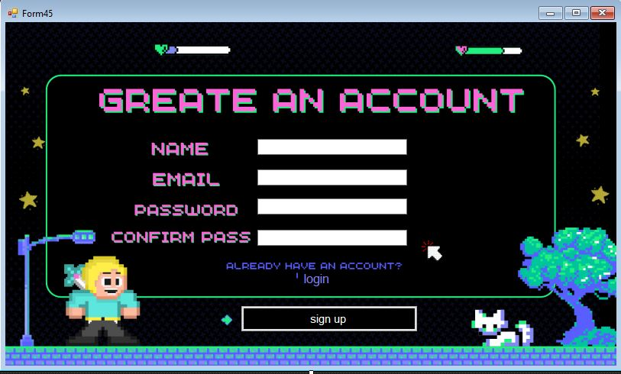

You'll need to re-enter your chosen password to confirm it and ensure there are no typos.

A secure password to protect your account. It should be a combination of letters, numbers, and special characters for better security.

Figure 1

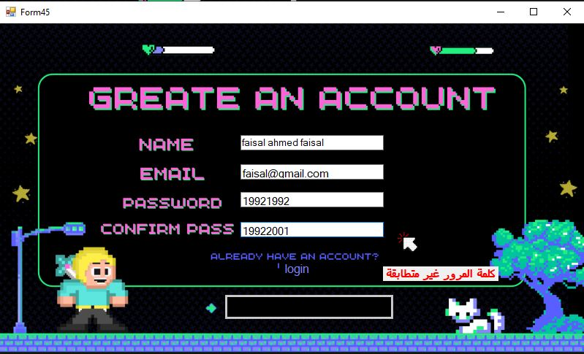

Figure 2

* + 1. **login page**

Users input their password to access their account securely.

Users enter their email address associated with their account.

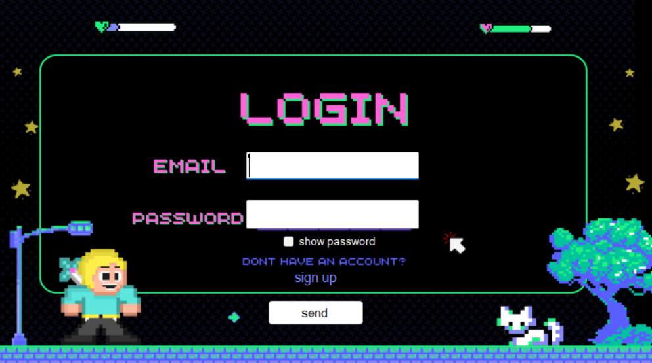

Figure 3

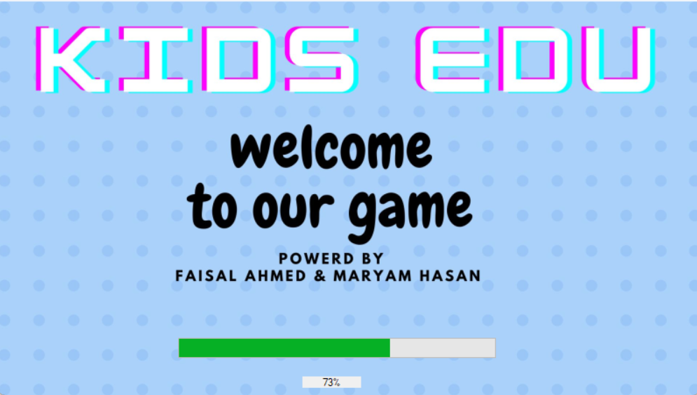



Figure 4

* + 1. **Categories**

here are the five categories you've provided:

Geography, Sciences, Stories, Mathematics and Challenges

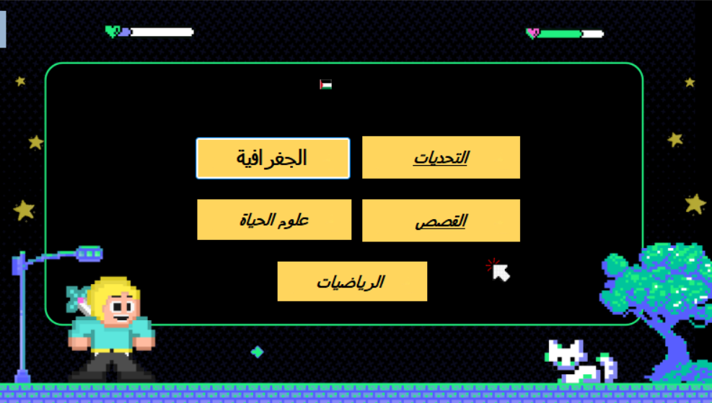

Figure 5

* + - 1. **Geography**

Geography section includes a set of geographical questions

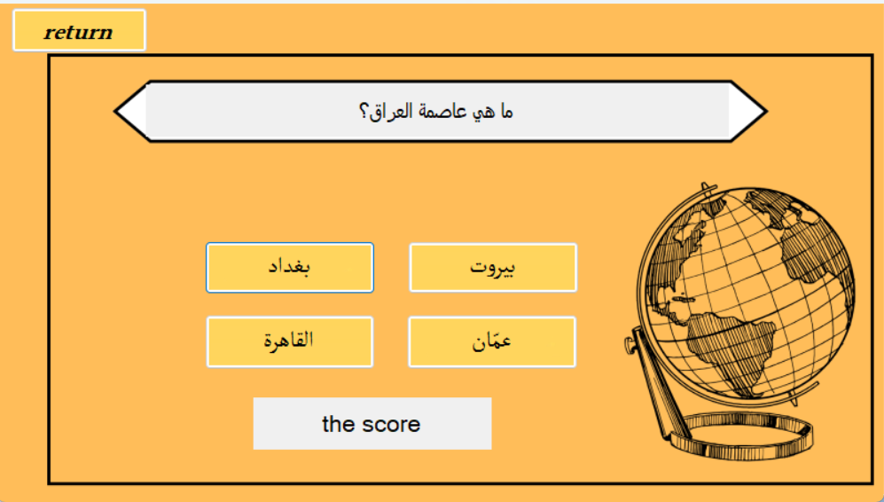

Figure 6

* + - 1. **Sciences**

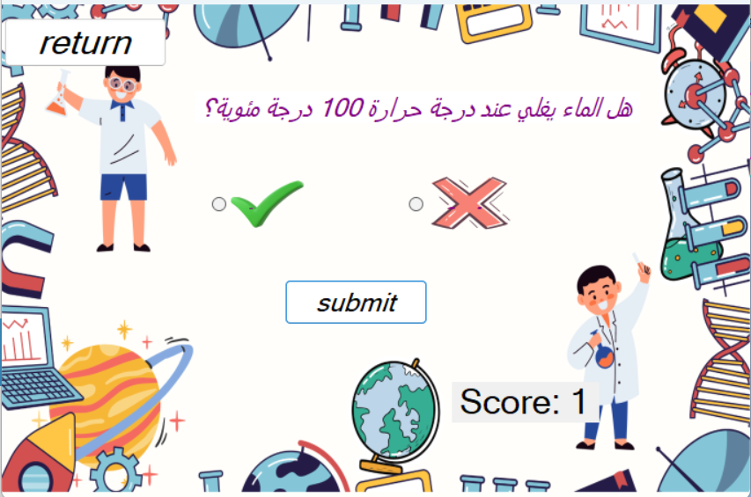

Figure 7

**3.4.3.3 Challenge**

Here we have a challenge between two players

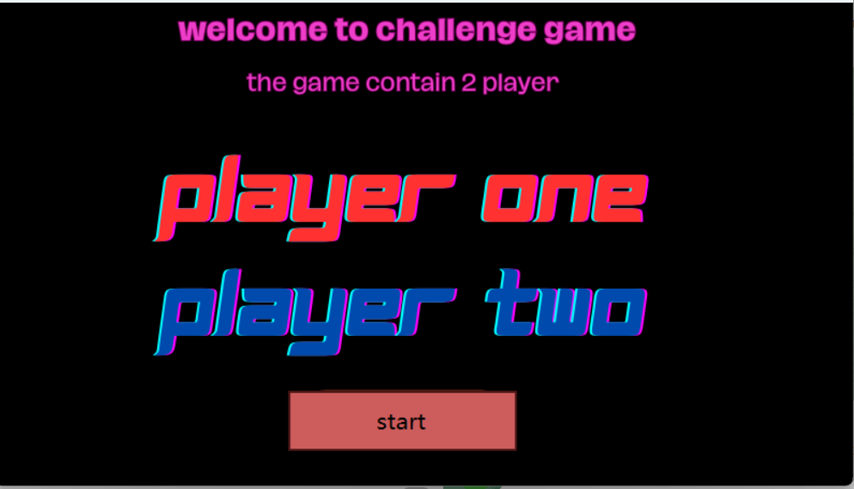

Figure 8

First player name

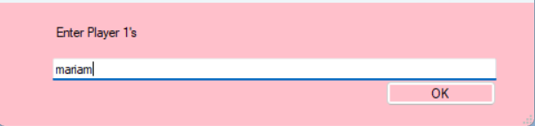

Figure 9

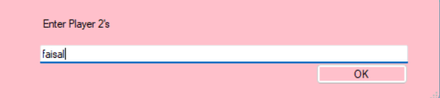

Second player name

Figure 10

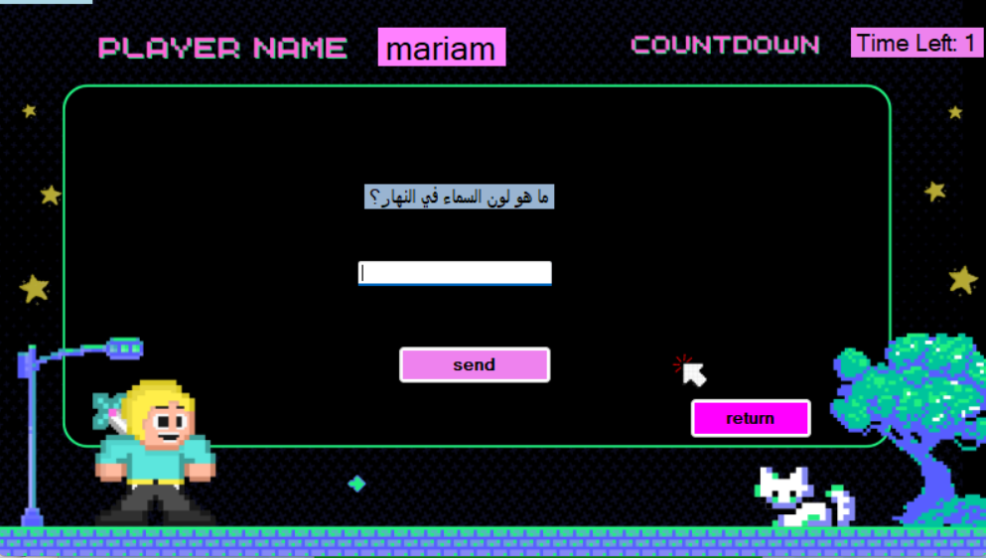

Figure 11

**3.4.3.4 Math**

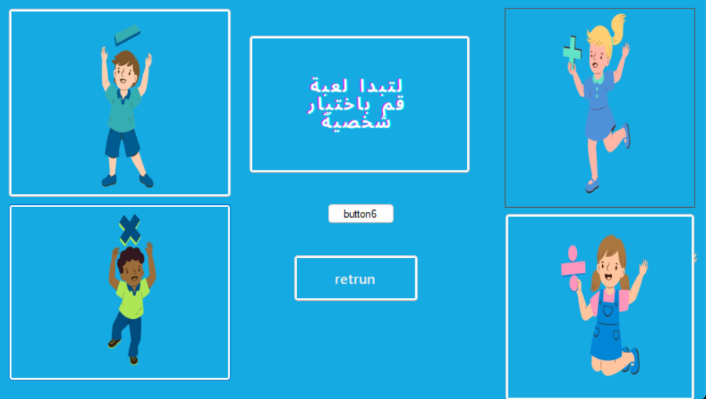

Choose the mathematical operation you want to learn

Figure 12

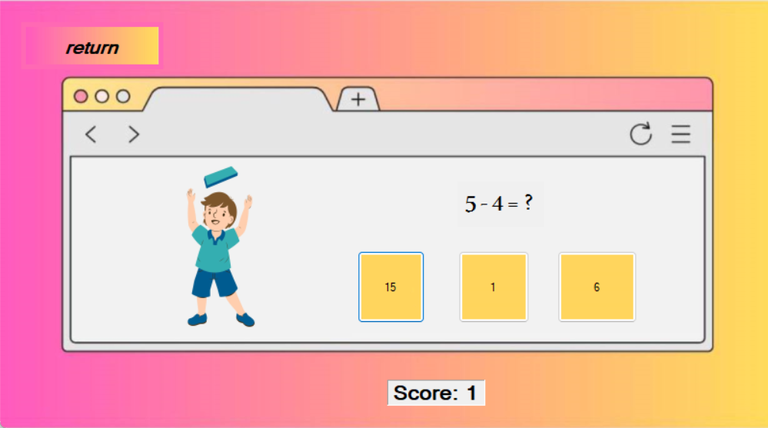

Figure 13

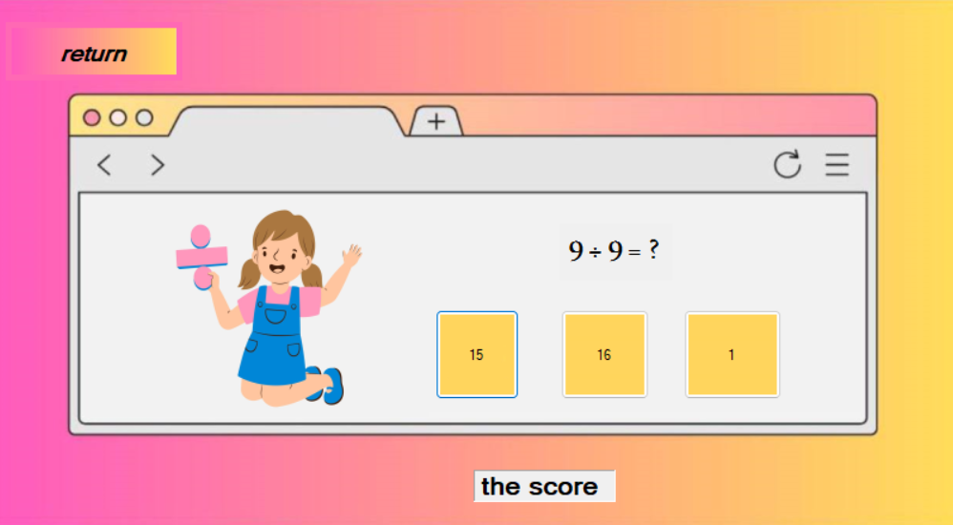

Figure 14

**3.4.3.5 Stories**



Figure 15

Some useful and interesting stories

* + 1. ***Database***

game has been successfully linked to a database and server to store player information. Currently, player data, including name, email address, and password, is being saved to ensure a safe and reliable gaming experience. In the future, we will update the system to save player progress and enable game resumption from where they left off. This means that upon logging in, your personal information, including your progress in the game, will be displayed automatically. We look forward to continuously enhancing your gaming experience.

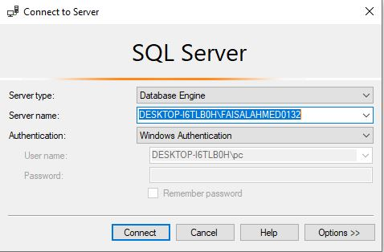

***Figure 16***

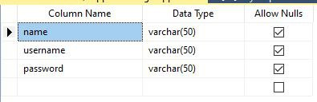

***Figure 17***

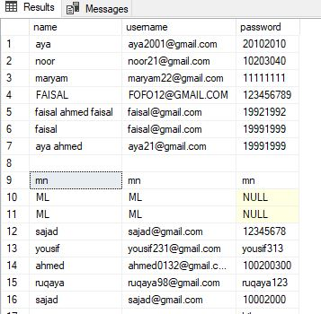

***Figure 18***

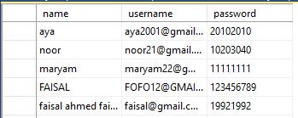

***Figure 19***

***Email and password***

***Chapter Four***

**Conclusion and Future Work**

This chapter will be a summary and possible future work for our game

**Chapter four**

**4.1 Conclusion**

The goal of this game is to teach children some general information in various specializations, to increase the children’s cultural level and instill in them the spirit of learning and knowledge, by giving them some tests in the form of a game so that they can benefit while playing. The game is designed to be easy to use for children, as children can choose topics and answers easily, and of course the questions are suitable for children.

This game aims to make some of the time children spend using the Internet productive by teaching them some things that will benefit them in school or real life.

**4.2 Future Work**

* Expanding the content: increasing the information and paragraphs contained in the game so that it contains the greatest possible amount of information and benefit for children.
* Personalization: Future work can explore personalization features that allow parents customize the app based on their child's level of knowledge and learning goals. This includes the ability to set learning targets, adjust the difficulty level of activities, and track progress.
* Social features: The app can incorporate social features that allow children to connect with other learners, share their progress and achievements, and compete with others in learning activities. This can help foster a sense of community and motivation among learners.
* Feedback and assessment: The app can incorporate feedback and assessment features that provide children with immediate feedback on their learning progress. This can include automated assessments, teacher feedback, and peer assessments
* Interactive quizzes and games: To enhance engagement and motivation, the game include interactive quizzes and games that allow children to test their knowledge and reinforce what they have learned
* The game supports English in the future

## **References**

# *[1] James Paul Gee, learning by design: Good Video Games as Learning Machines, Researchgate, 2005*

# *[2] Constance Steinkuehler, “Games and Learning”, academia,2014*

*[3] Rhona J. Sharpe,” The Student Experience of E-learning in Higher Education: A Review of the Literature”, Researchgate, January 2005*

*[4] Sarah J. Mukherjee, Lucia Bugallo, Teresa Cremin,” Conceptions of play by children in five countries towards an understanding of playfulness”, December 2022*

*[5] Dimitrios Vlachopoulos, “The effect of games and simulations on higher education: a systematic literature review”, International Journal of Educational Technology in Higher Education ,2017*

*[6] Jan L. Plass, “Foundations of Game-Based Learning”, Educational Psychologist,   
October 2015*

*[7] Pablo M. Ger, D. Burgos,” Educational game design for online education”, Computers in Human Behavior, September 2018*

*[8] Alan Fogel, Eva Nwokah, J. Karns, “Parent-infant games as dynamic social systems”, Researchgate ,January 1993*

# *[9] Luke C. Jackson, “Analysing digital educational games with the*Games as Action, Games as Text*framework”, sciencedirect, July 2022*

*[10] M. Prensky, “Digital Game-Based Learning”, January 2001*

*[11] Khuda Bakhsh, Muhammad Hafeez, Shumaila Shahzad, Bushra Naureen Muhammad Faisal Farid, “Effectiveness of Digital Game Based Learning Strategy in Higher Educational Perspectives”, 2022*

# *[12] Erica L. Zippert, “Preschool children's math exploration during play with peers”, sciencedirect, December 2019*

*[13] Khuda Bakhsh, Muhammad Hafeez, Shumaila Shahzad, Bushra Naureen, Muhammad Faisal Farid, “Effectiveness of Digital Game Based Learning Strategy in Higher Educational Perspectives”, 2022*

*[14] Jaipaul Roopnarine, “Cultural Variations in Beliefs about Play, Parent-Child Play, and Children's Play: Meaning for Childhood Development”, January 2012*

*[15] [26] Kathleen Dollard,* [*"Summary of What's New in this Release of Visual Studio 2022 version 17.9.6"*](https://learn.microsoft.com/en-us/visualstudio/releases/2022/release-notes#1796--visual-studio-2022-version-1796). April 15, 2024*.*

# *[16]* [*"InfoQ eMag: A Preview of C# 7"*](https://www.infoq.com/minibooks/emag-c-sharp-preview) from the original on April 24, 2023*. Retrieved November 11, 2016*.

*[17] Kathleen Dollard,* [*"Announcing C# 12"*](https://devblogs.microsoft.com/dotnet/announcing-csharp-12/)*. Retrieved November 18, 2023*.

*[18]* Torgersen, Mads (October 27, 2008). [*"New features in C# 4.0"*](https://web.archive.org/web/20120103195731/http:/code.msdn.microsoft.com/csharpfuture/Release/ProjectReleases.aspx?ReleaseId=1686). [*Microsoft*](https://en.wikipedia.org/wiki/Microsoft). Archived from [*the original*](http://code.msdn.microsoft.com/csharpfuture/Release/ProjectReleases.aspx?ReleaseId=1686) on January 3, 2012*. Retrieved October 28, 2008*.

*[19]* [*"The Roslyn .NET compiler provides C# and Visual Basic languages with rich code analysis APIs.: dotnet/roslyn"*](https://github.com/dotnet/roslyn). November 13, 2019

*[20]* [*stephentoub*](https://github.com/dotnet/coreclr/commits?author=stephentoub)*,* [*danmoseley*](https://github.com/dotnet/coreclr/commits?author=danmoseley)*,* [*"CoreCLR is the runtime for .NET Core. It includes the garbage collector, JIT compiler, primitive data types and low-level classes.: dotnet/coreclr"*](https://github.com/dotnet/coreclr). November 13, 2019.

# *[21]* [*Danmoseley*](https://github.com/dotnet/coreclr/commits?author=danmoseley)*,*[*"Visual Studio 2017 version 15.7 Release Notes"*](https://learn.microsoft.com/en-us/visualstudio/releasenotes/vs2017-relnotes-v15.7). Microsoft Learn. July 13, 2022

*[22] D. Burgos,* [*"What's new in C# 8.0"*](https://docs.microsoft.com/en-us/dotnet/csharp/whats-new/csharp-8). Microsoft Docs. March 9, 2023.

[23] [*stephentoub*](https://github.com/dotnet/coreclr/commits?author=stephentoub)*,* [*"Visual Studio 2019 version 16.8 Release Notes"*](https://learn.microsoft.com/en-us/visualstudio/releases/2019/release-notes-v16.8). Microsoft Learn. April 11, 2023.

[24] *Bushra Naureen* [*"What's new in C# 10"*](https://docs.microsoft.com/en-us/dotnet/csharp/whats-new/csharp-10). Microsoft Learn. [*Archived*](https://web.archive.org/web/20220208222424/https:/docs.microsoft.com/en-us/dotnet/csharp/whats-new/csharp-10) from the original on February 8, 2022

[25] *, Bushra Naureen* [*"What's new in C# 12"*](https://learn.microsoft.com/en-us/dotnet/csharp/whats-new/csharp-12). Microsoft Learn. [*Archived*](https://web.archive.org/web/20230720114545/https:/learn.microsoft.com/en-us/dotnet/csharp/whats-new/csharp-12) from the original on July 20, 2023*.*

*[26]* Copsey, Reed Jr. (December 13, 2011). [*"Which language is Visual Studio developed in?"*](https://social.msdn.microsoft.com/Forums/en-US/a109279a-8fc0-4f4c-9887-41a73a7ab679/which-language-is-visual-studio-developed-in?forum=vseditor). Microsoft Developer Network*.*

*[27]* [*Adam Hughes*](https://www.techtarget.com/contributor/Adam-Hughes)*,*[*"Visual Studio 2022 Product Family System Requirements"*](https://docs.microsoft.com/en-us/visualstudio/releases/2022/system-requirements). Microsoft*. Retrieved December 29, 2021*.

*[28]* [*"Microsoft Visual Studio 2015 Language Pack"*](https://www.microsoft.com/en-us/download/details.aspx?id=48157). [*Microsoft*](https://en.wikipedia.org/wiki/Microsoft), September 12, 2016*.*

*[29]* [*Adam Hughes*](https://www.techtarget.com/contributor/Adam-Hughes)*,* [*"Visual Studio Downloads"*](https://www.visualstudio.com/downloads/). Visual Studio. Microsoft. [*Archived*](https://web.archive.org/web/20181226042854/https:/visualstudio.microsoft.com/downloads/) from the original on December 26, 2018*.*

*[30]* Brenner, Pat (July 19, 2013). [*"C99 library support in Visual Studio 2013"*](https://devblogs.microsoft.com/cppblog/c99-library-support-in-visual-studio-2013/). Visual C++ Team Blog. Microsoft

[31] *James Paul Gee ,*[*"F# at Microsoft Research"*](https://www.microsoft.com/en-us/research/project/f-at-microsoft-research/). [*Microsoft*](https://en.wikipedia.org/wiki/Microsoft). [*Archived*](https://web.archive.org/web/20190401163549/https:/www.microsoft.com/en-us/research/project/f-at-microsoft-research/) from the original on April 1, 2019*. Retrieved July 22, 2019*.

[32] *Alan Fogel* [*"Visual Studio Product Lifecycle and Servicing"*](https://docs.microsoft.com/en-us/visualstudio/productinfo/vs-servicing). Microsoft Docs. October 26, 2021*.*

*[33]* [*Adam Hughes*](https://www.techtarget.com/contributor/Adam-Hughes)[*"Visual Studio Development Environment Model"*](https://web.archive.org/web/20081019173446/http:/msdn.microsoft.com/en-us/library/bb165114(VS.80).aspx). Microsoft. Archived from [*the original*](https://msdn.microsoft.com/en-us/library/bb165114(VS.80).aspx) on October 19, 2008.

[34] *Erica L. Zippert,*  [*"VSPackages and Managed Package Framework (MPF)"*](https://web.archive.org/web/20090113011526/http:/msdn.microsoft.com/en-us/library/bb166554(VS.80).aspx). Microsoft. Archived from [*the original*](https://msdn.microsoft.com/en-us/library/bb166554(VS.80).aspx) on January 13, 2009*.*

*[35]* Mehta, Vijay. [*"Extending Visual Studio 2005"*](http://www.codeguru.com/csharp/.net/net_vs_addins/visualstudioadd-ins/article.php/c11835/). CodeGuru. [*Archived*](https://web.archive.org/web/20100317230720/http:/www.codeguru.com/csharp/.net/net_vs_addins/visualstudioadd-ins/article.php/c11835) from the original on March 17, 2010*.*

*[36] Erica L. Zippert,* [*"Language Service Essentials"*](https://msdn.microsoft.com/en-us/library/bb166391(VS.80).aspx). [*MSDN*](https://en.wikipedia.org/wiki/MSDN). [*Microsoft*](https://en.wikipedia.org/wiki/Microsoft). [*Archived*](https://web.archive.org/web/20090112050427/http:/msdn.microsoft.com/en-us/library/bb166391(VS.80).aspx) from the original on January 12, 2009

[37] *James Paul Gee,* [*"Babel Package Overview"*](https://msdn.microsoft.com/en-us/library/bb165670(VS.80).aspx). [*MSDN*](https://en.wikipedia.org/wiki/MSDN). [*Microsoft*](https://en.wikipedia.org/wiki/Microsoft). [*Archived*](https://web.archive.org/web/20090112161704/http:/msdn.microsoft.com/en-us/library/bb165670(VS.80).aspx) from the original on January 12, 2009*.*

*[38]* [*"Managed Language Services overview"*](https://msdn.microsoft.com/en-us/library/bb166360(VS.80).aspx). [*MSDN*](https://en.wikipedia.org/wiki/MSDN). [*Microsoft*](https://en.wikipedia.org/wiki/Microsoft). [*Archived*](https://web.archive.org/web/20090112123045/http:/msdn.microsoft.com/en-us/library/bb166360(VS.80).aspx) from the original on January 12, 2009

[39] [*Jessica Sirkin*](https://www.techtarget.com/contributor/Jessica-Sirkin)*,* [*Adam Hughes*](https://www.techtarget.com/contributor/Adam-Hughes)*, “*[*Microsoft-SQL-Server-Management-Studio-SSMS*](https://www.techtarget.com/searchdatamanagement/definition/Microsoft-SQL-Server-Management-Studio-SSMS) *”, 2022*

*[40] Alan Fogel* [*"Download SQL Server Management Studio (SSMS)"*](https://docs.microsoft.com/sql/ssms/download-sql-server-management-studio-ssms). 2024-04-09*.*

*[41] Eva Nwokah* [*"What is SQL Server Management Studio (SSMS)?"*](https://docs.microsoft.com/en-us/sql/ssms/sql-server-management-studio-ssms?view=sql-server-ver16). microsoft.com. 2022-01-28*.*

*[42]* [*"Manage Objects by Using Object Explorer"*](https://docs.microsoft.com/en-us/sql/ssms/object/manage-objects-by-using-object-explorer?view=sql-server-ver16=). microsoft.com. 2022-01-18*.*

*[43]* Pat, [*"C99 library support in Visual Studio 2013"*](https://devblogs.microsoft.com/cppblog/c99-library-support-in-visual-studio-2013/), July 19, 2013

*[44] Luke C. Jackson* [*"Visual Studio 2019 version 16.8 Release Notes"*](https://learn.microsoft.com/en-us/visualstudio/releases/2019/release-notes-v16.8). Microsoft Learn. 11, 2013.

*[45]* Vijay. [*"Extending Visual Studio 2013"*](http://www.codeguru.com/csharp/.net/net_vs_addins/visualstudioadd-ins/article.php/c11835/). CodeGuru.  March 17, 2010*.*

*[46] dotnet, rosly* [*"The Roslyn .NET compiler provides C# and Visual Basic languages with rich code analysis APIs."*](https://github.com/dotnet/roslyn). November 13, 2019

*[47] Erica L. Zippert,*  [*"VSPackages and Managed Package Framework (MPF)"*](https://web.archive.org/web/20090113011526/http:/msdn.microsoft.com/en-us/library/bb166554(VS.80).aspx). Microsoft January 13, 2009*.*

*[48] Luke C. Jackson,* [*"Babel Package Overview"*](https://msdn.microsoft.com/en-us/library/bb165670(VS.80).aspx). [*MSDN*](https://en.wikipedia.org/wiki/MSDN). [*Microsoft*](https://en.wikipedia.org/wiki/Microsoft), January 12, 2019*.*

*[49] Constance Steinkuehler,* [*"Announcing SQL Server Management Studio – June 2015 Release"*](https://docs.microsoft.com/en-us/archive/blogs/sqlreleaseservices/announcing-sql-server-management-studio-june-2015-release). SQL Release Services Blog. Microsoft. 24 June 2015*. Retrieved 7 September 2015*.

*[50]* Reed Jr. [*"SSMS 18.0 (preview 4)"*](https://docs.microsoft.com/en-us/sql/ssms/sql-server-management-studio-changelog-ssms?view=sql-server-2017#ssms-180-preview-4download-sql-server-management-studio-ssmsmd). SQL Server Management Studio - Changelog (SSMS). Microsoft. 24 September 2018*.*